# Workshop 8 - Week 11 - CSY2085 – Server Administration and Security

## Workshop: Database Server

STUDENT NAME: Muhammad Raza

STUDENT NUMBER: 21624838

## Task 1 - Setting up Apache Webserver for User Home Pages

1. Edit the index.html file and put the following text: “Hello from [InitialsMy Student ID]!”. Make sure that you change the [My Student ID] to your own student ID.

## 7 last

## Task 2 - Setting up a PHP info page

1. Now with your web browser, go to http://34.145.136.249/~phpuser/info.php. Make sure you use your own server’s IP address! You show see your version of the following page:

## Task 3 - Setting up the MySQL Database Server

## Click on the “mysql” database and Webmin will display the database tables within the “mysql” database. Capture this screen and paste your screenshot below: 8 sql

## Creating a new MySQL database and table

1. On the next screen, click on your new database and your Contacts table, to display its fields or columns. Capture this screen and paste your screenshot below:  
   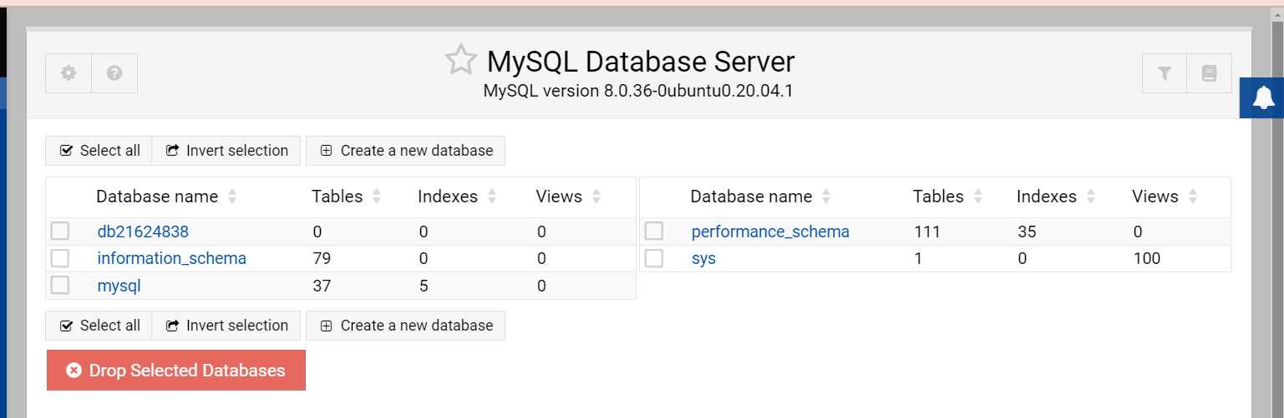

**Task 4 - Entering data into the Contacts table**

1. Enter the following SQL statement into the box and then click the "**Execute**" button. Make sure you get the spaces, commas, and single quotes correct:  
     
   **INSERT INTO Contacts VALUES ('Firstname Surname', 'Your address', 'Yourphone number', 'email@northampton.ac.uk');**

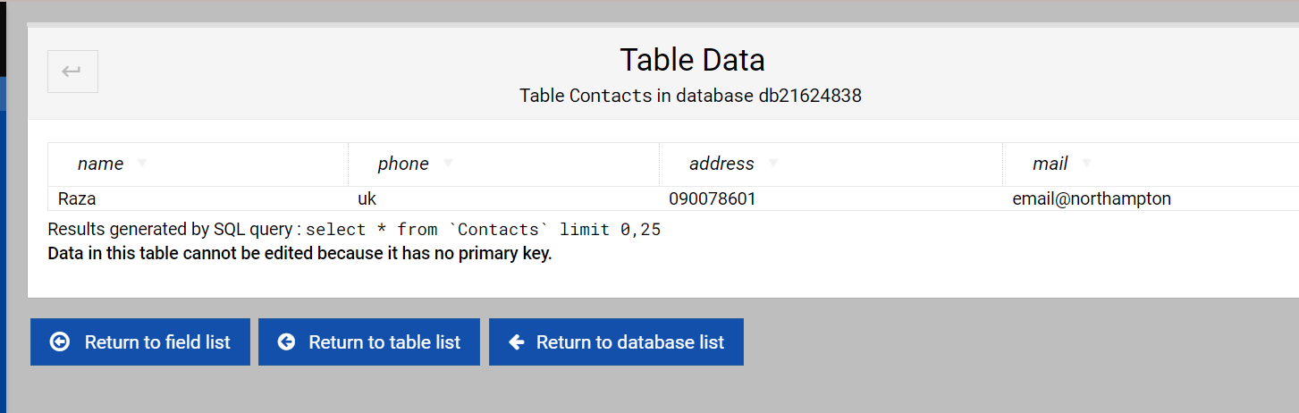

1. Repeat the procedure to create 4 more different contacts, using different values, and then capture the screen show all the contacts data, and paste it below:

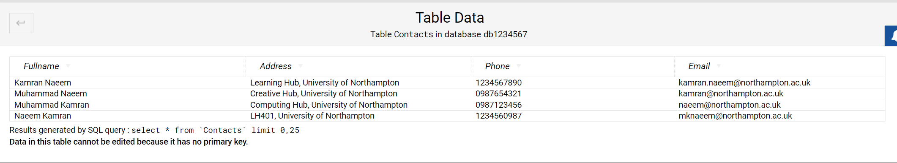

## Task 5 - Connecting Apache/PHP to MySQL

Now with your web browser, go to http://34.145.136.249/~phpuser/contacts.php. Make sure you use your own server’s IP address! You show see your version of the following page:  
  
